AI PRODUCT LEADERSHIP PROGRAM — CAPSTONE PROJECT
Use Case Document
Carrier Reliability & Selection Engine
Picks the most reliable carrier for each order, shows how confident that choice is, and explains it in plain language. Designed to be practical and buildable within the 26-week program.

1. Background & Context
Most e-commerce sellers and 3PLs assign orders to carriers using static rules: a fixed preference, a flat rate table, or a postal-code coverage map. None of these reflect how reliably a carrier actually performs on a specific lane. A carrier can underperform on a lane for months and keep getting chosen.
A second gap sits on top of the first: even when a carrier is chosen, the delivery date shown to the customer is a single number with no signal of how much to trust it. A shipment on a reliable lane on a normal Tuesday looks exactly as certain as one on a shaky lane during a festival peak.
This product closes both gaps with one model: for each eligible carrier it predicts not just whether the shipment will arrive on time, but how late it is likely to be if it slips. The planner gets a ranked, confidence-scored carrier choice with a short plain-language explanation.
Scope note: this is a generic, vendor-agnostic formulation. It does not reference or reproduce any specific platform's carrier logic, rate data, lead-time calculation, or customer configuration.

2. Use Case Definition

2.1 Actors
- 3PL / fulfillment planner choosing which carrier to allocate an order to
- E-commerce seller / operations manager who wants fewer late deliveries and more honest delivery promises
- End customer, who experiences the outcome of the carrier choice

2.2 Goal
Given an order and the carriers available for the lane, drop the carriers that cannot serve the destination, predict each remaining carrier's likelihood of arriving on time, one day late, or two or more days late, and recommend the most reliable carrier within a cost guardrail, with a confidence score and a short explanation.

2.3 Primary Flow
- An order arrives with origin, destination, service level, package details, and the list of carriers available for the lane.
- Coverage check: carriers that don't serve the destination are dropped. If the preferred carrier is dropped, the next eligible carrier is used (fallback).
- Cost guardrail: carriers priced above the set threshold relative to the cheapest eligible option are dropped.
- Reliability model: for each remaining carrier, predict the probability of on time, +1 day, and +2 days or more.
- Selection: pick the carrier with the highest on-time probability. If its confidence is at or above the threshold (e.g., 70%), the carrier is assigned automatically with no manual step. Most orders follow this path.
- Exceptions only: if even the best carrier is below the threshold, the order is flagged as at-risk and goes to the planner review queue, sorted by lowest confidence first. An LLM adds a two- or three-sentence reason so the planner can decide quickly to accept, switch carrier, or buffer the customer-facing date.
- The actual delivery outcome is logged and used to retrain the model.
Color key used in all diagrams: purple = people and app, blue = rules, green = machine learning, orange = GenAI, gray = data, peach = needs planner attention, yellow notes = the example order.
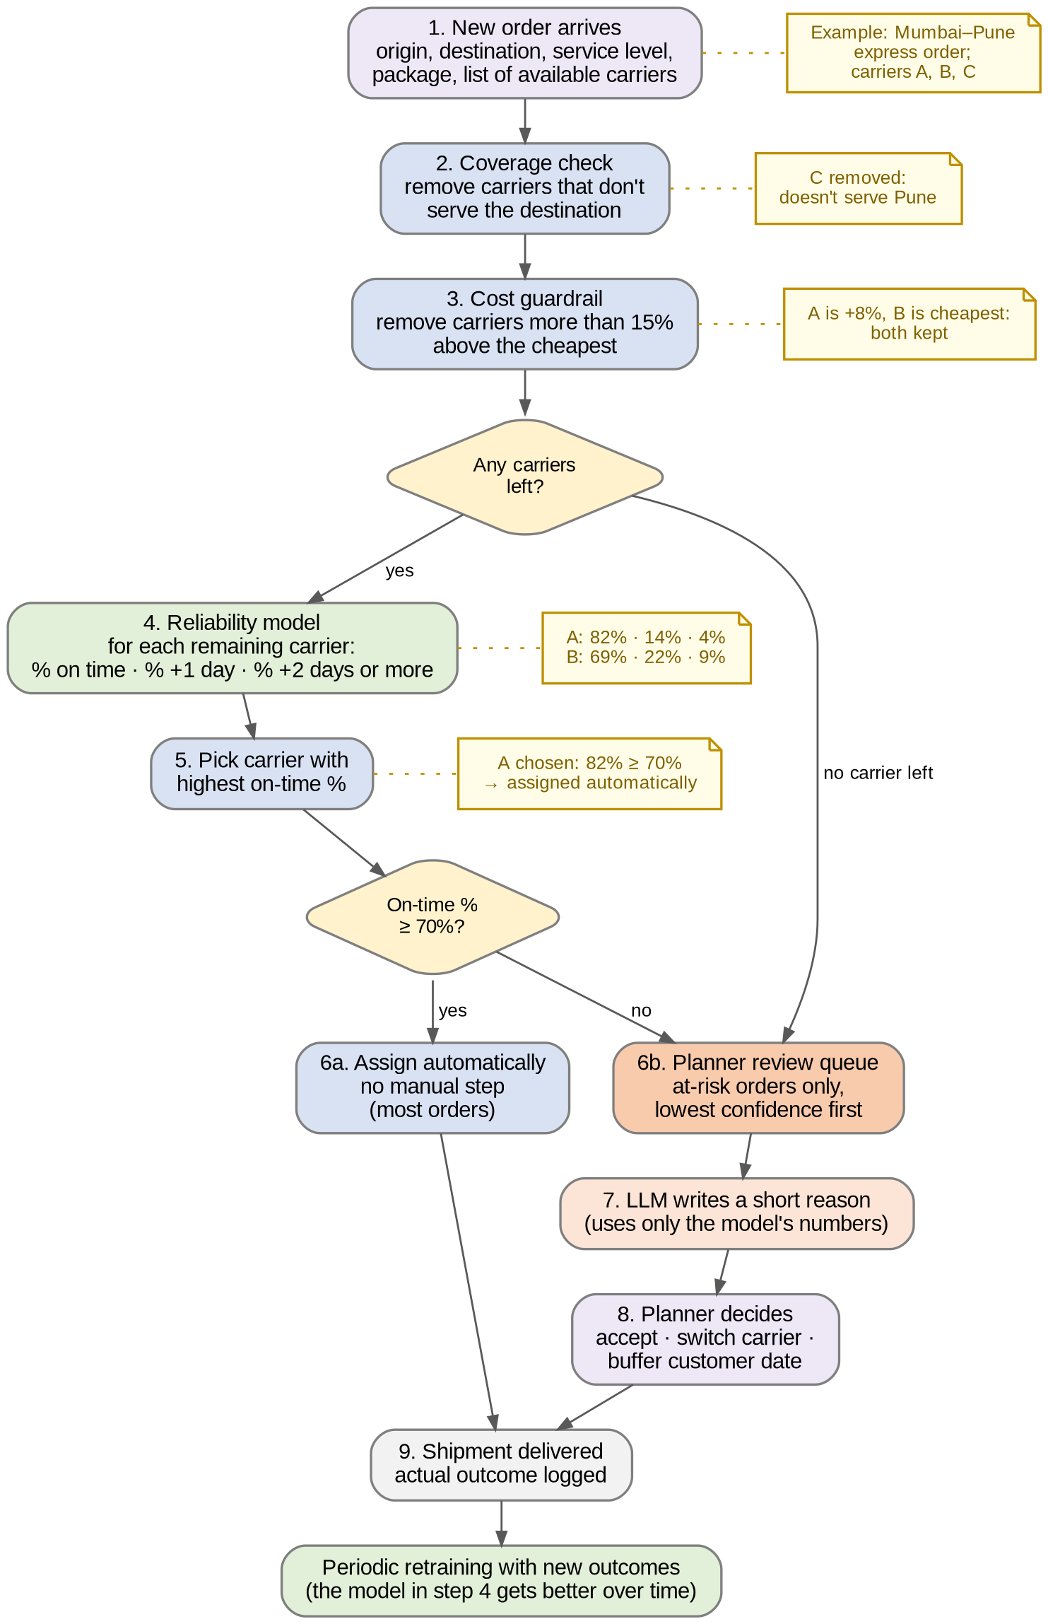
Figure 1. End-to-end workflow for one order (yellow notes follow the example order)

2.4 Example Walkthrough
The same example order is used in every diagram and in the output example (Section 11): an express order from Mumbai to Pune, with Carriers A, B, and C available.
Step | What happens | Example order
1. Order arrives | Order details and available carriers come in | Mumbai–Pune, express; Carriers A, B, C
2. Coverage check | Carriers that don't serve the destination are removed | C removed: doesn't serve Pune
3. Cost guardrail | Carriers more than 15% above the cheapest are removed | A is +8%, B is cheapest: both kept
4. Reliability model | Predicts on time / +1 day / +2 days or more | A: 82% / 14% / 4%; B: 69% / 22% / 9%
5. Pick carrier | Highest on-time % wins | Carrier A
6. Confidence check | At or above 70%: assign automatically. Below: review queue | 82% ≥ 70%: assigned automatically, no planner step
If it were below 70% | Planner sees it in the queue with a short LLM reason | e.g., if A were 64%, the planner would decide: accept, switch, or buffer the date
7. Delivery | Actual outcome is logged and used in the next retraining | Arrived on time: added to history

3. Problem Statement
Carrier assignment today is static, driven by preference, flat rules, or cost alone, with no feedback from actual delivery performance. Underperforming carriers keep getting chosen on bad lanes, and planners get no advance warning that a specific shipment is likely to slip. They find out only after the delivery is late.

4. Pain Points
Pain point | Who it affects | Why it happens
Carriers chosen by static rule or cost, not real reliability | Planners, customers | No performance signal feeds into carrier selection
Underperforming carriers keep getting picked on bad lanes | 3PL planners | No feedback loop from delivery outcomes
Preferred carrier sometimes can't serve the destination | Ops, customers | Coverage isn't checked before assignment
At-risk shipments discovered only after they're late | Ops, support | Delivery promises carry no confidence signal
Planners can't easily see or question carrier performance | Planners | Performance data isn't surfaced per lane in a usable form

5. Business & Customer Impact
- Fewer late and failed deliveries: reliable carriers chosen per lane reduce avoidable failures and re-ship costs.
- Early warning: only low-confidence orders are flagged for review, so planners spend time on the few orders that need it instead of checking every parcel.
- Trust in the recommendation: plain-language explanations make the model's choice easy for planners to accept or challenge.
- Objective carrier scorecards: lane-level reliability supports fact-based carrier reviews.

6. Goals & Success Criteria
- Model ranks carriers better than the static-rule baseline (higher on-time rate for recommended carriers in back-testing).
- Honest confidence: orders scored at about 70% on-time confidence arrive on time about 70% of the time.
- A meaningful share of late shipments were flagged as at-risk in advance.
- Explanations are accurate to the model output (checked on a sample; no invented reasons).

7. Scope

In scope (MVP)
- A working dataset of orders, carriers, lanes, and delivery outcomes to develop and demonstrate the engine
- Coverage check with fallback, and a simple cost guardrail (rule-based)
- One machine learning model that predicts the three delivery outcomes (on time, +1 day, or +2 days or more) for each order-carrier pair
- Carrier recommendation with confidence score and at-risk flag
- Automatic assignment for confident orders; review queue for at-risk orders only
- LLM explanation for flagged orders (and on demand for any order)
- Planner assistant with 3 tools (see Section 9.2)
- A simple web app for planners (review queue, lane dashboard, and assistant chat)

Out of scope (later roadmap)
- Cost-reliability optimization or rate shopping
- Live carrier APIs, real-time tracking, or live disruption/weather feeds
- Reading carrier advisories or news feeds
- Multi-leg or hub-and-spoke routing
- Integration with any real TMS or lead-time engine

8. Information the Engine Uses
Category | Examples
Historical performance | Carrier's trailing on-time rate on this lane and service level
Lane | Origin–destination pair, distance band, metro/rural
Package | Weight band, service tier (standard/express)
Temporal | Day of week, booking hour, month, peak/off-peak flag
Coverage & cost | Serves destination (yes/no), relative price; used by rules, not predicted
The engine draws on a handful of straightforward signals about each order and carrier:

9. Modeling & AI Approach

9.1 Reliability model (ML)
- Model: a machine learning model that sorts each order-carrier pair into one of three outcomes — on time, +1 day, or +2 days or more.
- Why three classes: the on-time probability drives carrier ranking, and the full split gives the confidence window without a second model.
- Cold start: if a carrier has too little history on a lane, fall back to its region-wide or overall on-time rate.
How the model learns and is used, in plain terms:
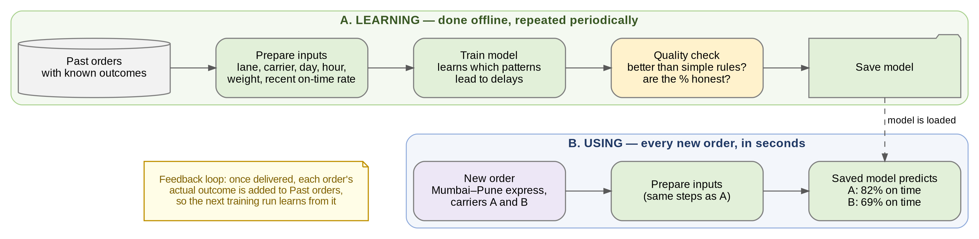
Figure 2. Model lifecycle: learning from past orders (top), then scoring each new order (bottom)

9.2 GenAI / agentic layer
Kept deliberately small: one explanation feature and one assistant with three tools.
- Explanation: the LLM receives the model output and a few supporting stats (e.g., lane on-time rate, peak flag) and writes a short reason. It is instructed to use only the provided numbers.
- Planner assistant: a tool-using assistant that can score an order, look up a lane’s on-time performance, and list the orders currently flagged as at-risk.
Example planner question: "Which carrier should I use for this Mumbai–Pune express order, and how sure are we?"
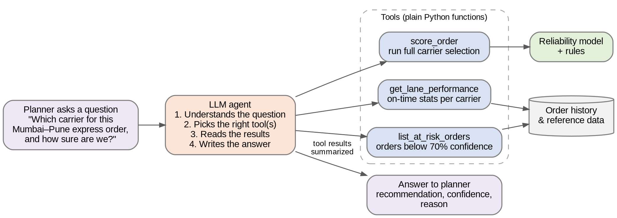
Figure 3. How the planner assistant answers a question

10. Solution Architecture
The product has five parts. Orders flow in at the top left, most are assigned automatically, and only at-risk orders reach the planner. The numbers on the arrows follow one order through the system.
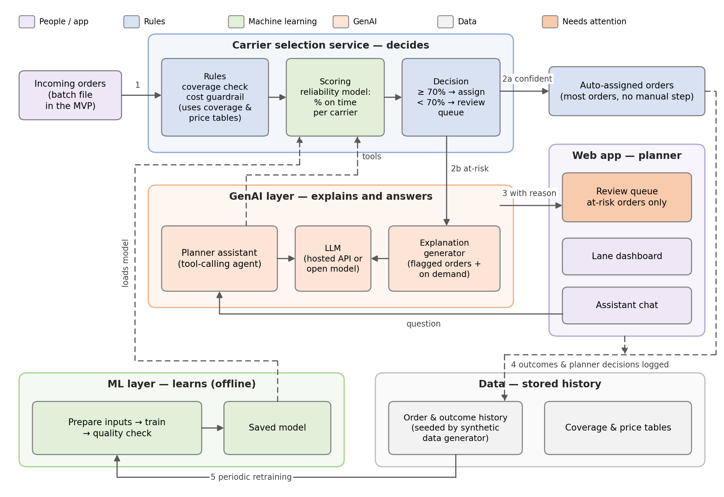
Figure 4. Solution architecture
Part | What it does
Carrier selection service | Applies coverage and cost rules, scores the remaining carriers, and decides: assign automatically or send to review
GenAI layer | Writes short reasons for flagged orders; answers planner questions using tools
Web app | Review queue for at-risk orders, lane dashboard, assistant chat
ML layer | Prepares inputs, trains and checks the model, saves versions
Data | Stores order history, outcomes, planner decisions, coverage, and prices

11. Output Specification
Example for an express order with three available carriers and a 15% cost guardrail:
Carrier | Covered? | Cost vs. cheapest | On time | +1 day | +2 days+ | Result
Carrier A | Yes | +8% | 82% | 14% | 4% | Recommended
Carrier B | Yes | Cheapest | 69% | 22% | 9% | Eligible
Carrier C | No | — | — | — | — | Excluded (coverage)
Confidence: 82% on time, above the 70% threshold, so Carrier A is assigned automatically. The order does not enter the planner review queue.
Explanation (shown on demand for auto-assigned orders): "Carrier A is recommended: it has delivered on time on 84% of recent express shipments on this lane, versus 67% for Carrier B, and costs 8% more, within the 15% limit. Carrier C does not serve this destination."

12. Open Questions for Team Review
- Where will the data come from: a public dataset or data we create ourselves?
- What counts as "on time": the date promised to the customer or the carrier's own delivery commitment?
- What cost limit and confidence threshold should we use for the demo (for example, 15% and 70%)?
- What should happen if no carrier passes the coverage and cost checks?
- How do we handle a new carrier with no delivery history?
- Which tools will we use to build it, given the team's mixed technical backgrounds?
Prepared as a team capstone use case for the AI Product Leadership Program (AIPL). Generic and vendor-agnostic; no proprietary carrier logic, rate data, or customer configuration from any specific platform is referenced or reproduced.

